create database insurance;

use insurance;

create table person(

driver_id varchar(10),

name varchar(20),

address varchar(30),

primary key(driver_id)

);

desc person;

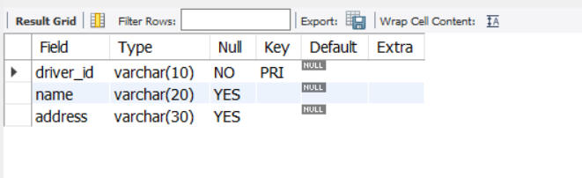

create table car(

reg_num varchar(10),

model varchar(10),

year int,

primary key(reg_num)

);

desc car;

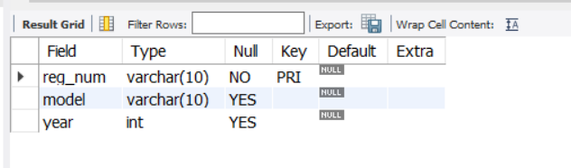

create table accident(

report_num int,

accident_date date,

location varchar(20),

primary key(report_num)

);

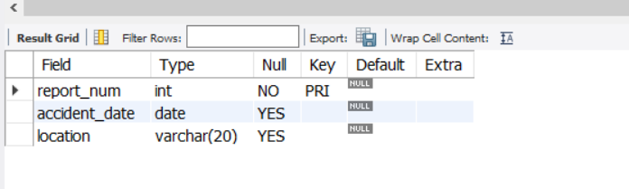

create table owns(

driver_id varchar(10),

reg_num varchar(10),

primary key(driver_id,reg_num),

foreign key(driver_id) references person(driver_id),

foreign key(reg_num) references car(reg_num)

);

desc owns;

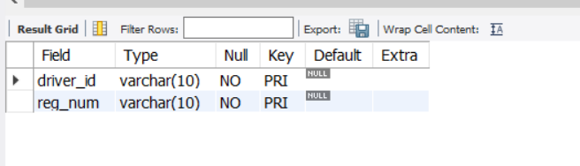

create table participated(

driver_id varchar(10),

reg_num varchar(10),

report_num int,

damage_amount int,

primary key(driver_id,reg_num,report_num),

foreign key(driver_id) references person(driver_id),

foreign key(reg_num) references car(reg_num),

foreign key(report_num) references accident(report_num)

);

desc participated;

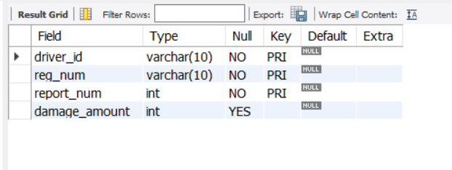

insert into person values('A01','Richard',' Srinivas Nagar');

insert into person values('A02','Pradeep','Rajajinagar');

insert into person values('A03','Smith','Ashoknagar');

insert into person values('A04','Venu','N.R.Colony');

insert into person values('A05','John','Hanumanth Nagar');

commit;

select * from person;

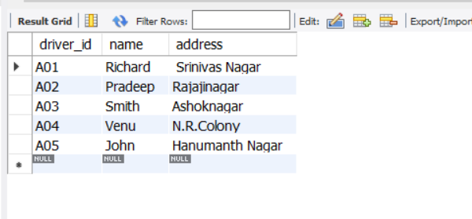

insert into car values('KA031181','Lancer',1957);

insert into car values('KA041702','Audi',2005);

insert into car values('KA043408','Honda',2008);

insert into car values('KA052250','Indica',1990);

insert into car values('KA095477','Toyota',1998);

commit;

select * from car;

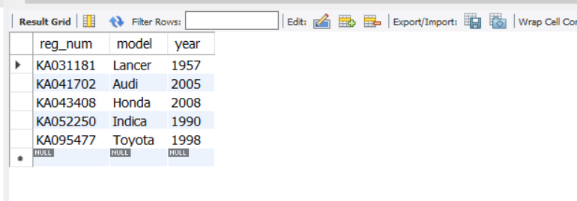

insert into accident values(11,'2001-01-03','Mysore Road');

insert into accident values(12,'2021-01-03','Southend Circle');

insert into accident values(13,'2020-03-03',' Bulltemple Road');

insert into accident values(14,' 2017-02-08',' Mysore Road');

insert into accident values(15,'2004-03-05','Kanakpura Road');

commit;

select * from accident;

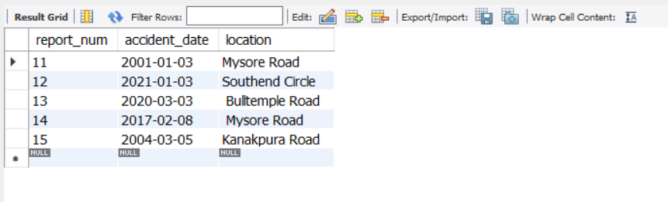

insert into owns values ('A01','KA052250');

insert into owns values ('A02','KA043408');

insert into owns values ('A03','KA031181');

insert into owns values ('A04','KA095477');

insert into owns values ('A05','KA041702');

commit;

select * from owns;

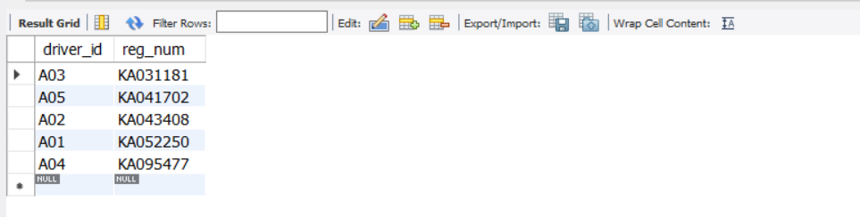

insert into participated values ('A01','KA052250',11, 25000);

insert into participated values ('A02','KA043408',12, 50000);

insert into participated values ('A03','KA031181',13, 25000);

insert into participated values ('A04','KA095477',14, 3000);

insert into participated values ('A05','KA041702',15, 5000);

commit;

select * from participated;

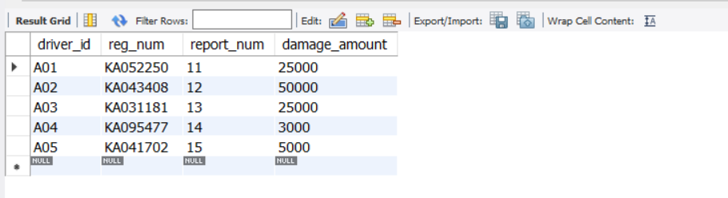

update participated

set damage_amount = 2500

where reg_num='KA031111';

select * from participated;

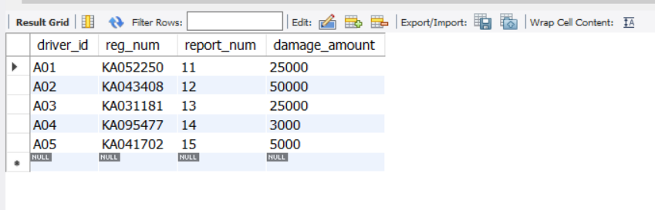

insert into accident values(101,'2020-12-01','Xavier Road');

insert into participated values('A01','KA031111',101, 1001);

commit;

select * from accident;

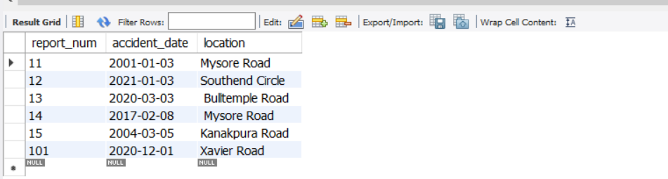

select * from participated;

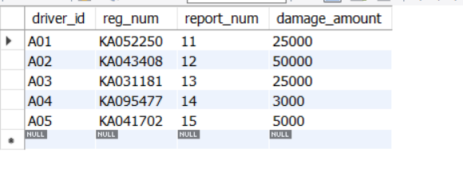

insert into car values('KA01010', 'Accord', 2002);

insert into owns values('A02', 'KA01010');

insert into accident values(200, '2008-12-01', 'Pinto Road');

insert into participated values('A02', 'KA01010', 200, 500);

commit;

select * from car;

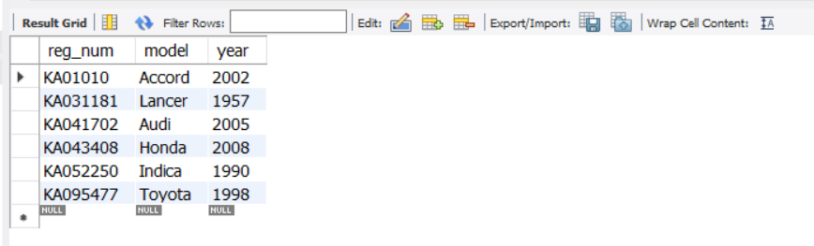

select * from owns;

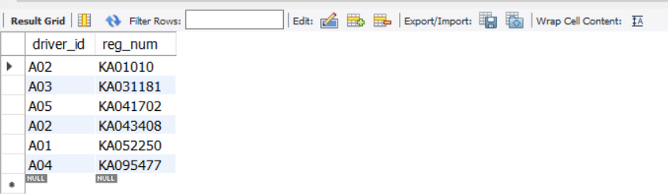

select * from accident;

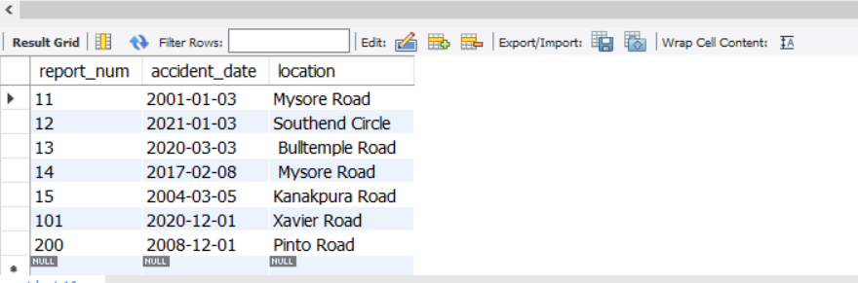

select * from participated;

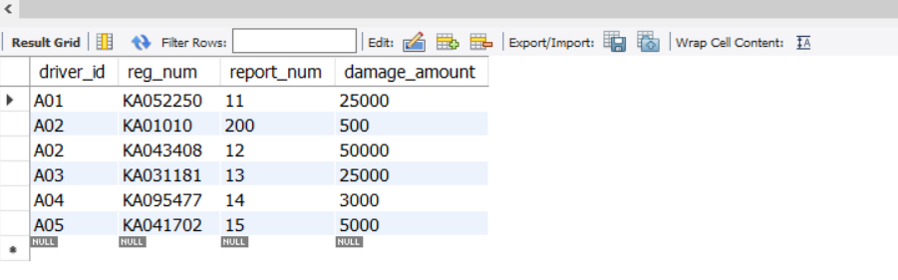

select count(*) from accident where year(accident_date)=2008;

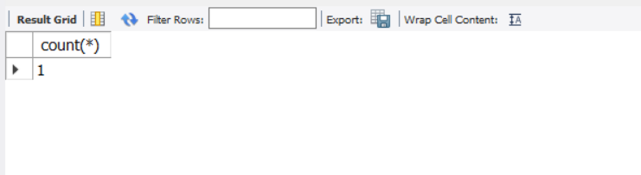

select count(*) from participated where reg_num in ( select reg_num from car where model="Accord");

